***Name: Kishan Dabhi***

Problem 1: Business Development

--------------------- Html ---------------------------------

<!DOCTYPE html>

<html lang="en">

<head>

<meta charset="UTF-8">

<meta name="viewport" content="width=device-width, initial-scale=1.0">

<title>Box Model - 1</title>

<link rel="stylesheet" href="style1.css">

</head>

<body>

<div class="box">

<h1 class="title"> Business <br> Development </h1>

<p class="body"> Have an idea or inquiry for Waze business development </p>

<button class="btn"> Share your ideas </button>

</div>

</body>

</html>

------------------- CSS -----------------------------------------------

*{

margin: 0;

padding: 10px;

box-sizing: border-box;

}

.box{

width: 500px;

margin: 200px auto;

padding: 100px 30px;

background-image: linear-gradient(rgb(0, 255, 174) ,rgb(9, 92, 92));

font-family: system-ui, -apple-system, BlinkMacSystemFont, 'Segoe UI', Roboto, Oxygen, Ubuntu, Cantarell, 'Open Sans', 'Helvetica Neue', sans-serif;

border-radius: 10px;

}

.title{

font-weight: 600;

font-size: 44px;

}

.body{

font-weight: 400;

font-size: 16px;

}

.btn{

background-color: white;

border: none;

border-radius: 30px;

font-size: 18px;

margin-top: 15px;

font-weight: 600;

padding: 12px 30px;

}

------------------------- Output -----------------------------------------------------------

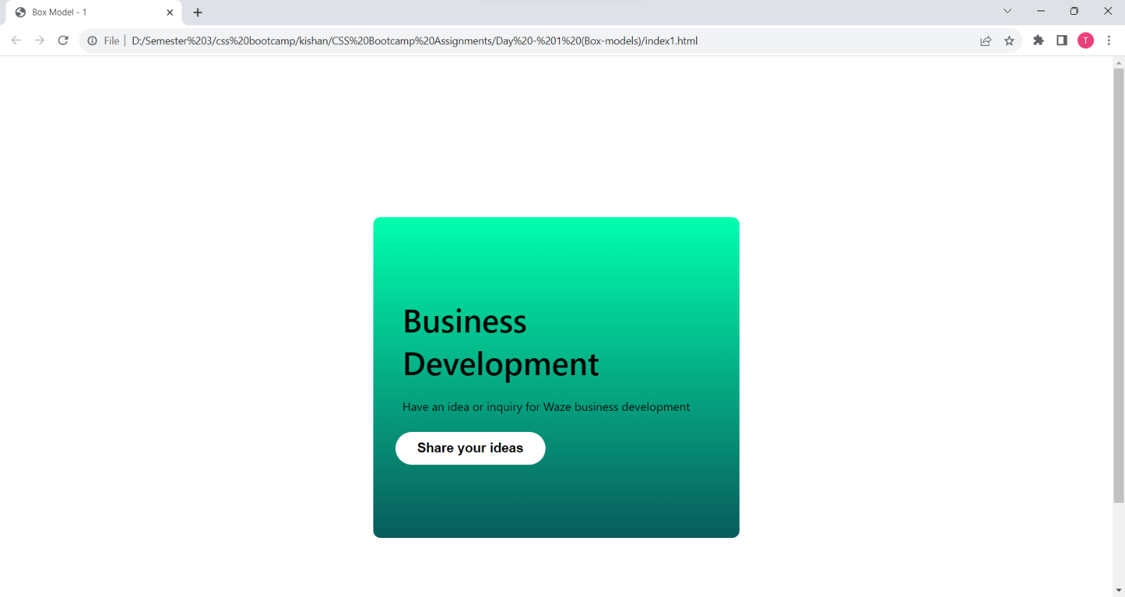

Problem 2: Profiles

--------------------- Html ---------------------------------

<!DOCTYPE html>

<html>

<head>

<meta charset="utf-8" />

<meta name="viewport" content="width=device-width, initial-scale=1" />

<title>Box Model - 2</title>

<link rel="stylesheet" href="style2.css">

</head>

<body>

<div class="profile-card">

<div class="card-body">

<div class="card-title">

<h3>Your profiles</h3>

</div>

<div>

<p>See how your profiles appear in Google services</p>

</div>

</div>

<img src="./avatar1.png" class="avatar" />

<img src="./avatar2.jpg" class="avatar" />

<div class="card-footer">

<a href="#" class="link-profile">See profiles</a>

</div>

</div>

</body>

</html>

----------------------------- CSS -----------------------------------

* {

margin: 0;

padding: 0;

box-sizing: border-box;

}

.profile-card {

width: 550px;

margin: 100px auto;

font-family: sans-serif;

border: 2px solid lightgray;

border-radius: 10px;

}

.card-body {

padding: 25px;

margin-bottom: 10px;

}

.card-title {

font-size: 30px;

font-weight: 100;

margin: 30px 0px;

}

.avatar {

width: 100px;

margin-left: 40px;

margin-bottom: 40px;

border-radius: 50%;

}

.card-footer {

border-top: 2px solid lightgray;

padding: 20px;

}

.link-profile {

text-decoration: none;

}

----------------------- Output --------------------------

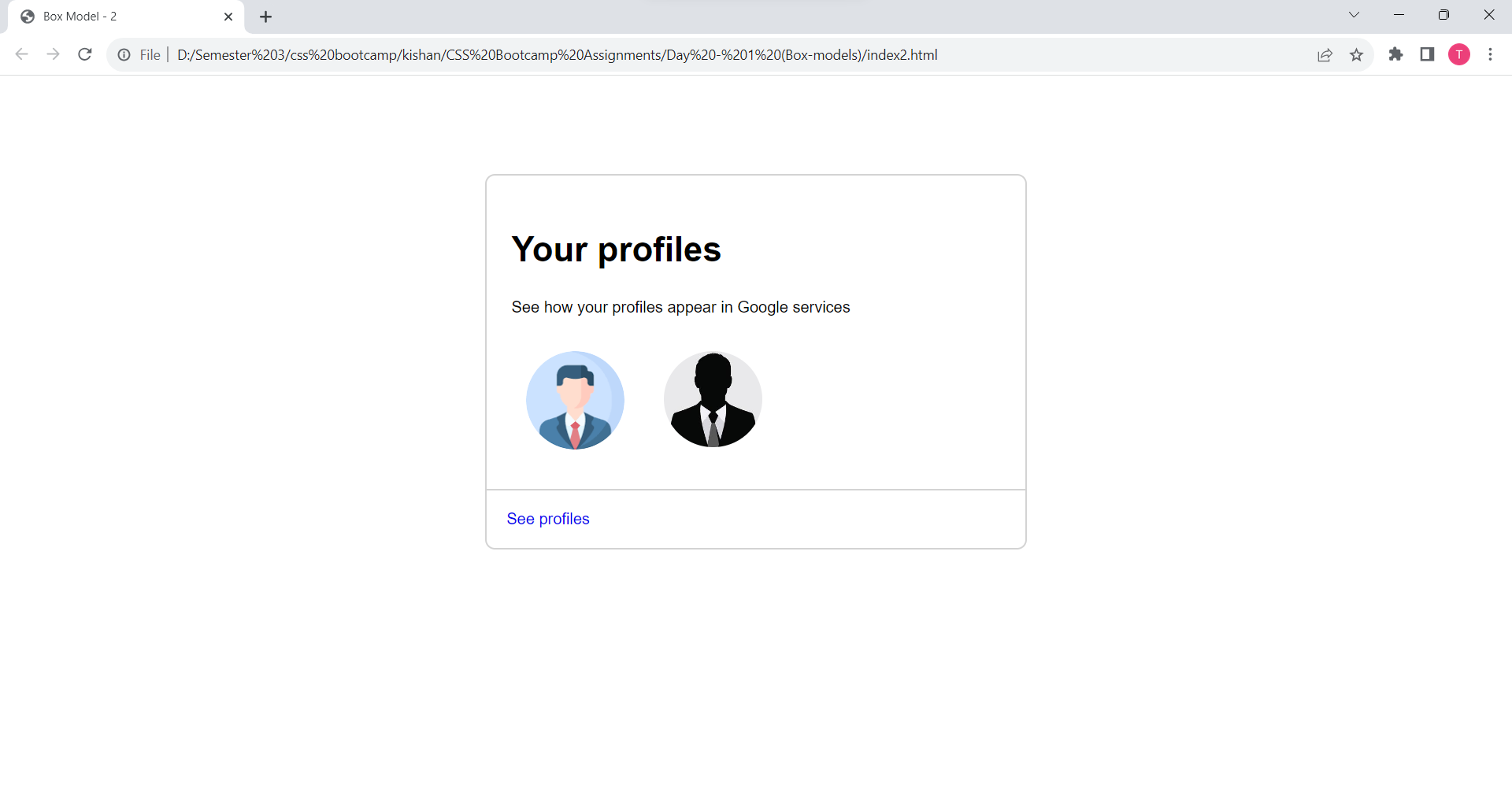

Problem 3: Google Photos

--------------------- Html ---------------------------------

<!DOCTYPE html>

<html>

<head>

<meta charset="utf-8" />

<meta name="viewport" content="width=device-width, initial-scale=1" />

<title>Box Model - 3</title>

<link rel="stylesheet" href="style3.css" />

</head>

<body>

<div class="card">

<div>

<img src="mountain.avif" class="card-img" />

</div>

<div class="card-body">

<div>

<div class="small-img">

<img src="lock.png" class="img" />

</div>

<p>SUBSCRIBE TO ANY PLAN</p>

</div>

<div class="card-title">

<h3>Get more features in Google Photos</h3>

</div>

<div class="card-text">

<p>

Bring your favorite moments to life with more Google Photos editing

tools for Android and iOS, including Magic Eraser. Subject to

eligibility.

</p>

</div>

<button class="btn">View details</button>

</div>

</div>

</body>

</html>

--------------------------- CSS -------------------------------------------

.card {

width: 450px;

margin: 100px auto;

border: 1px solid lightgray;

border-radius: 10px;

font-family: system-ui, -apple-system, BlinkMacSystemFont, "Segoe UI", Roboto,

Oxygen, Ubuntu, Cantarell, "Open Sans", "Helvetica Neue", sans-serif;

}

.small-img {

float: left;

width: 15px;

margin-right: 10px;

}

.img {

width: 100%;

}

.card-img {

width: 100%;

border-top-left-radius: 10px;

border-top-right-radius: 10px;

}

.card-body {

padding: 20px;

}

.card-title {

font-size: 24px;

}

.card-text {

color: gray;

}

.btn {

margin: 10px 0px;

padding: 10px;

background-color: white;

border: 1px solid lightgray;

color: blue;

font-size: 15px;

border-radius: 5px;

}

------------------------------------ Output -------------------------------------------

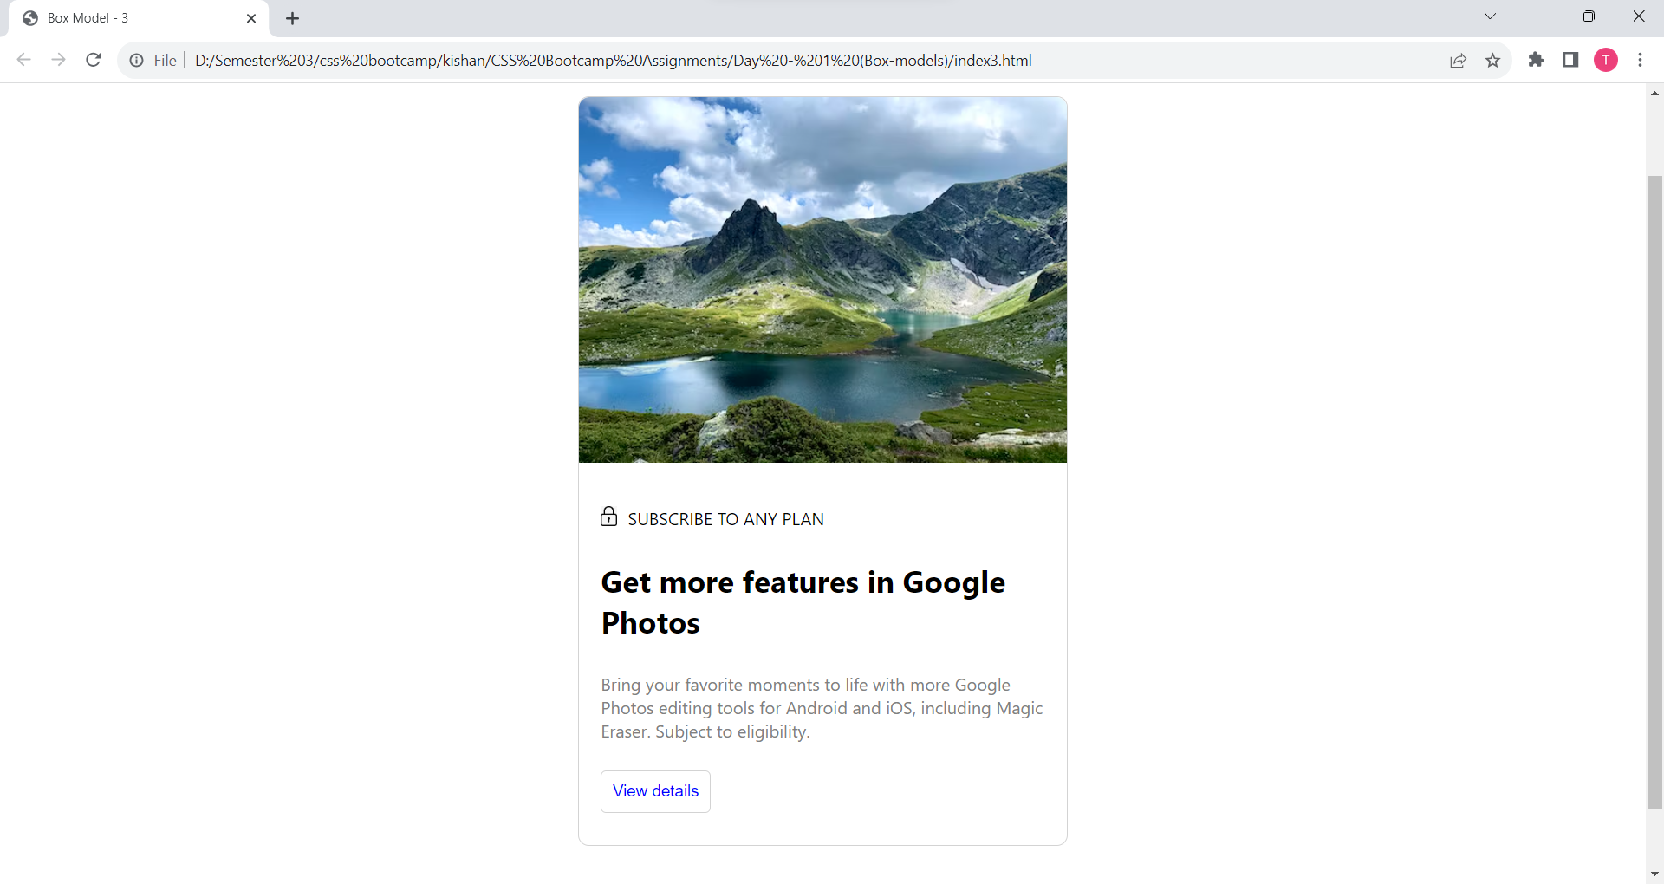

Problem 4: Flodesk

--------------------- Html ---------------------------------

<!DOCTYPE html>

<html>

<head>

<meta charset="utf-8" />

<meta name="viewport" content="width=device-width, initial-scale=1" />

<title>Box Model-4</title>

<link rel="stylesheet" href="style4.css" />

</head>

<body>

<div class="card">

<div class="card-img">

<img src="flodesk.png" class="img" />

</div>

<div class="card-title">

<h5>Welcome back!</h5>

</div>

<div>

<input type="text" placeholder="Enter your email" class="input" />

<input

type="password"

placeholder="Enter your password "

s

class="input"

/>

</div>

<div class="div-btn">

<button class="btn">Log in to Flodesk</button>

</div>

<div class="card-link">

<span>

<a href="#" class="link-noline">Not a member?</a>

</span>

<span>

<a href="#" class="link">Sign up</a>

</span>

<br />

<span>

<a href="#" class="link">Forgot your password?</a>

</span>

</div>

<div class="card-footer">

<p>

By continuing, you agree to Flodesk's

<a href="#" class="footer-link">terms</a>

and acknowledge you've read our

<a href="#" class="footer-link">privacy policy</a>

</p>

</div>

</div>

</body>

</html>

--------------------------- CSS --------------------------------------

*{

font-family: system-ui, -apple-system, BlinkMacSystemFont, 'Segoe UI', Roboto, Oxygen, Ubuntu, Cantarell, 'Open Sans', 'Helvetica Neue', sans-serif;

}

.card {

width: 500px;

margin: 100px auto;

padding: 40px;

font-family: sans-serif;

text-align: center;

}

.img{

width: 250px;

}

.card-title {

width: 100%;

font-size: 25px;

font-weight: 600;

text-align: center;

}

.input {

width: 80%;

margin-bottom: 10px;

padding: 15px;

border-radius: 10px;

border: 1px solid lightgray;

}

.btn {

border: none;

padding: 15px;

padding-left: 50px;

padding-right: 50px;

margin: 20px;

font-size: 18px;

background-color: black;

color: white;

border-radius: 40px;

text-align: center;

}

.link-noline {

text-decoration: none;

color: gray;

}

.link {

color: black;

}

.card-link {

margin: 10px;

padding: 10px;

}

.card-footer {

margin: 20px;

color: gray;

}

.footer-link {

color: gray;

}

----------------------------- Output -------------------------------------------------

